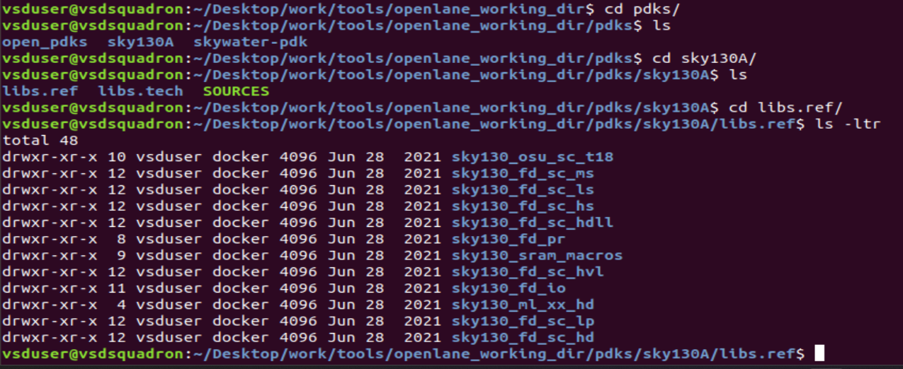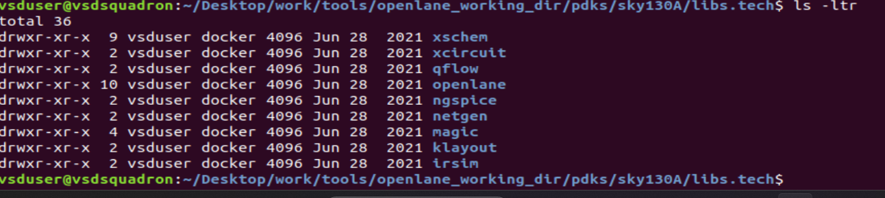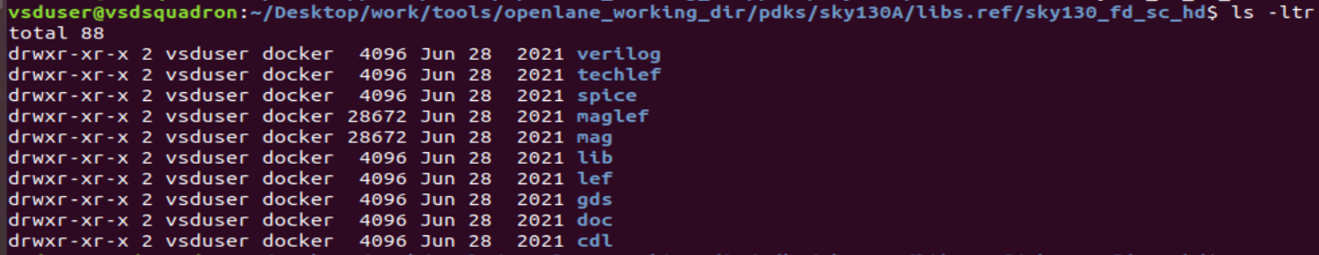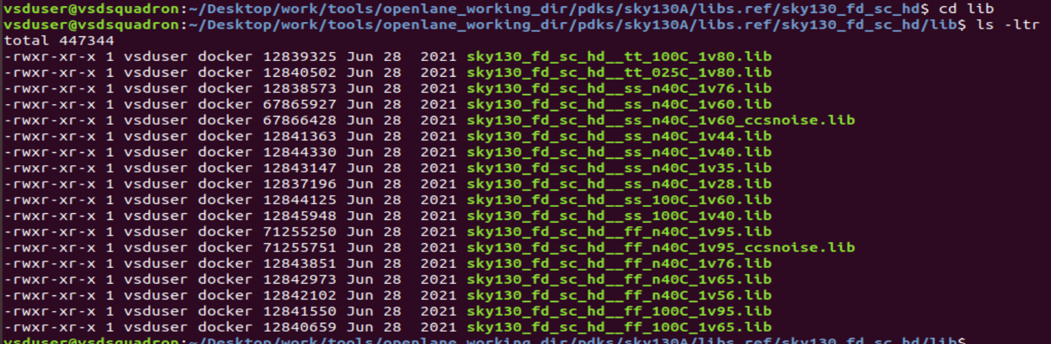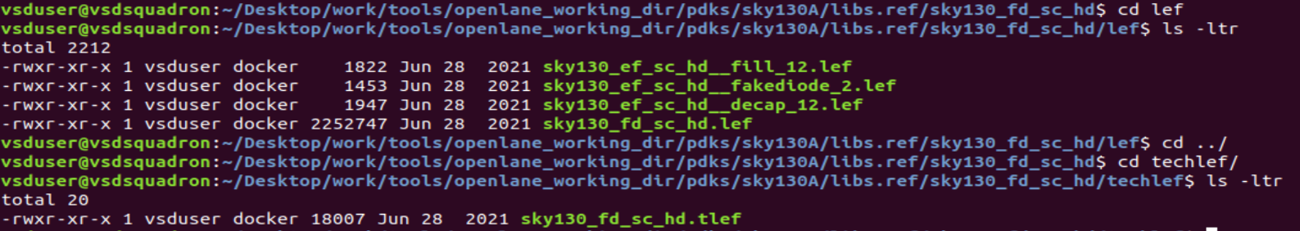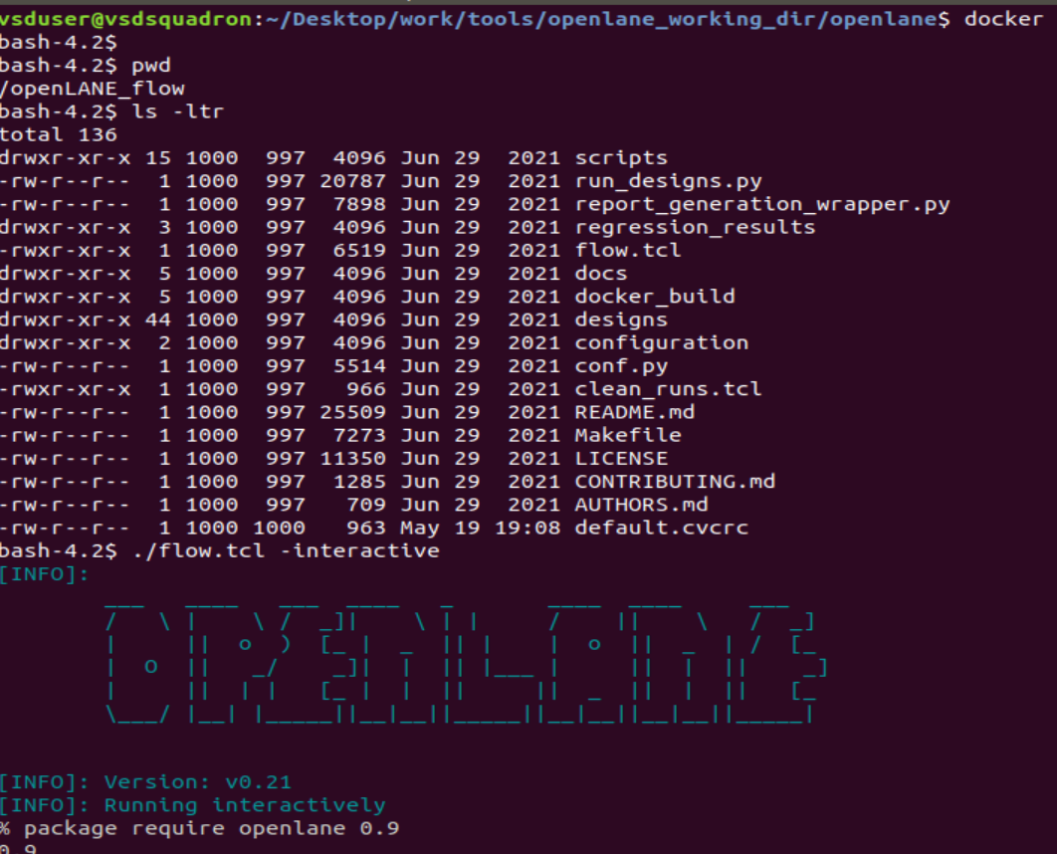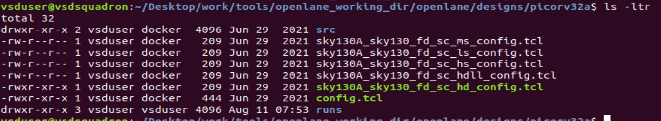

Config.tck=l

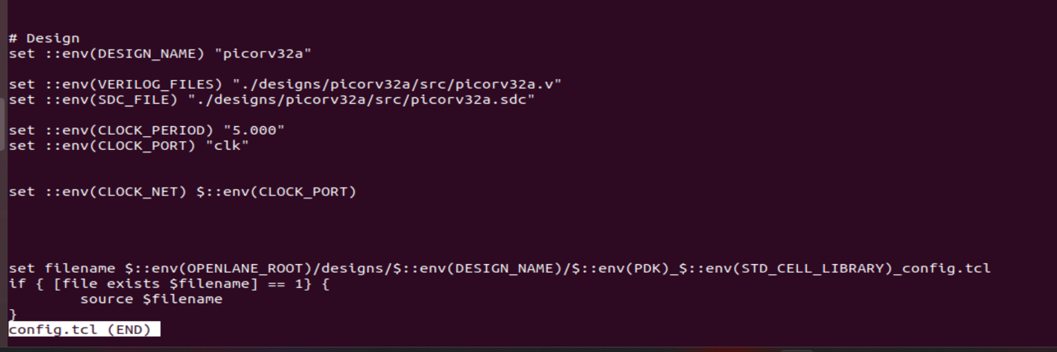

After running synthesis theses are the results

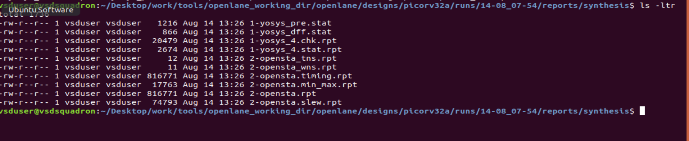

Day 2

Before floorplan readme file contain the all variables and their description is present

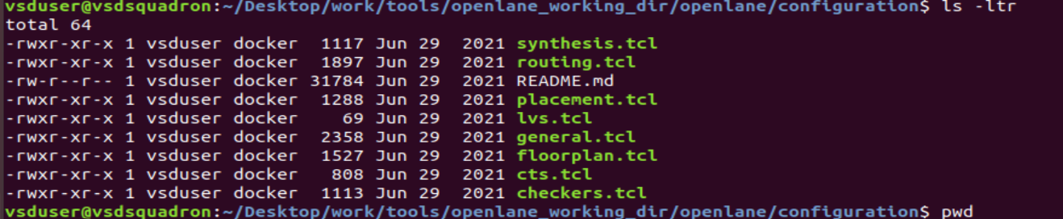

It contains the variables for all the flows

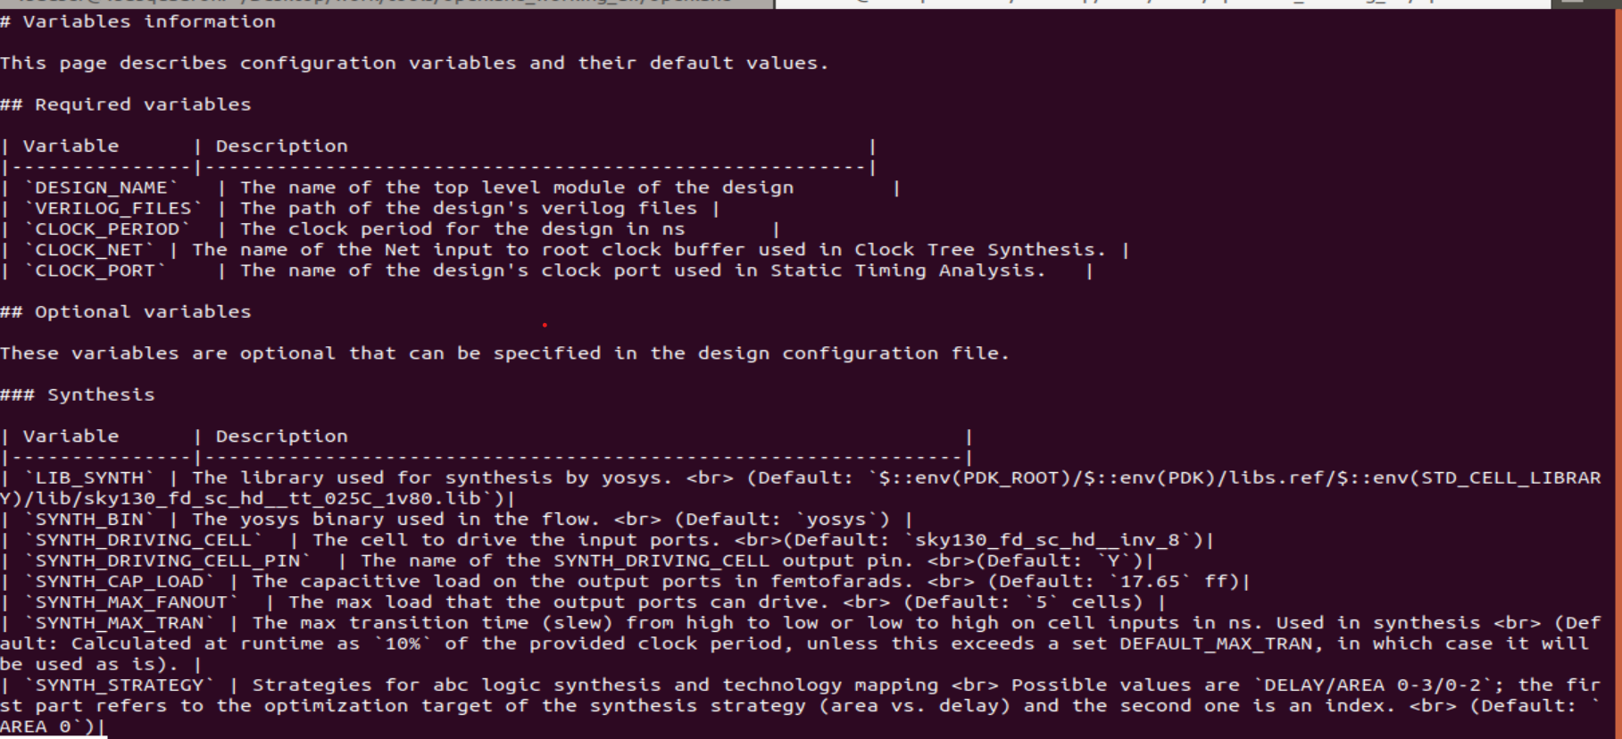

In floorplan all the details are been set with respect to config .tcl

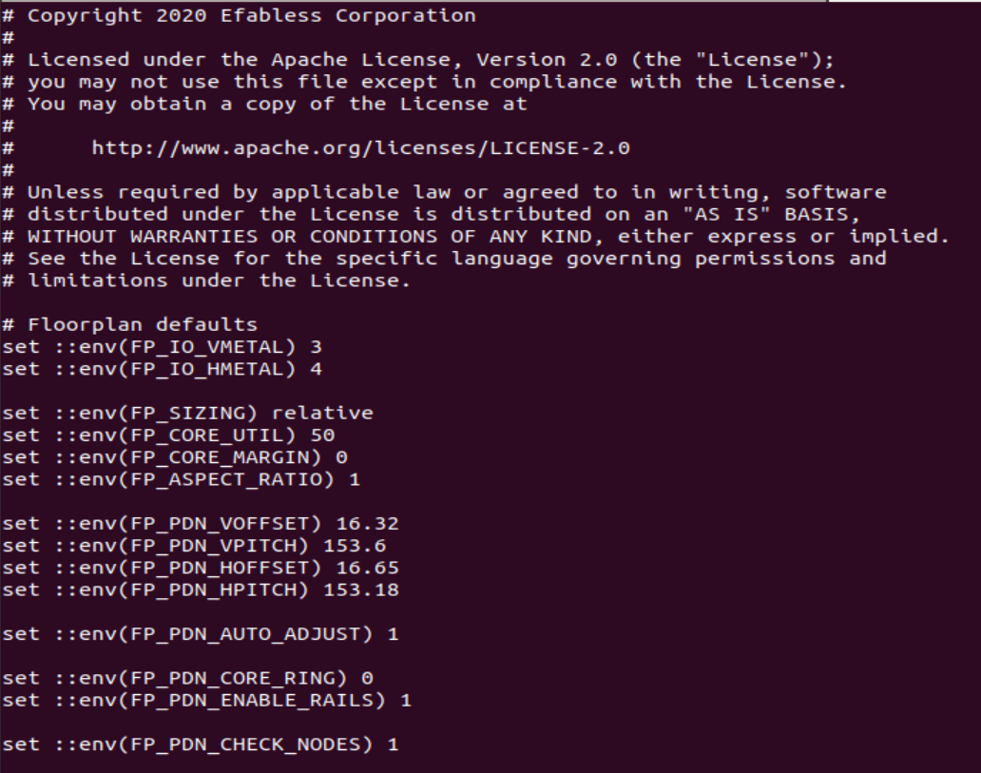

After running run_floorplan in openlean it will be successfully run and some metal layer are fixed with width pitch and offset and macros are placed

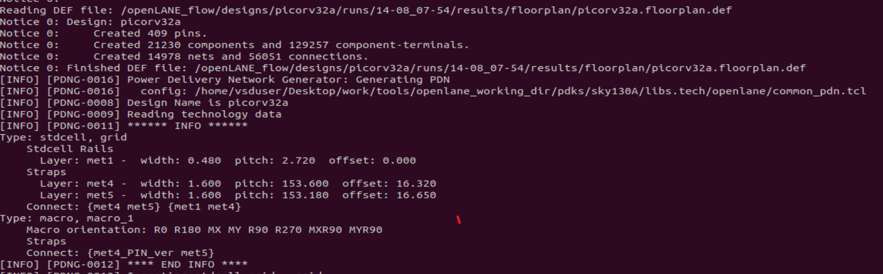

Floorplan def file contains all the information 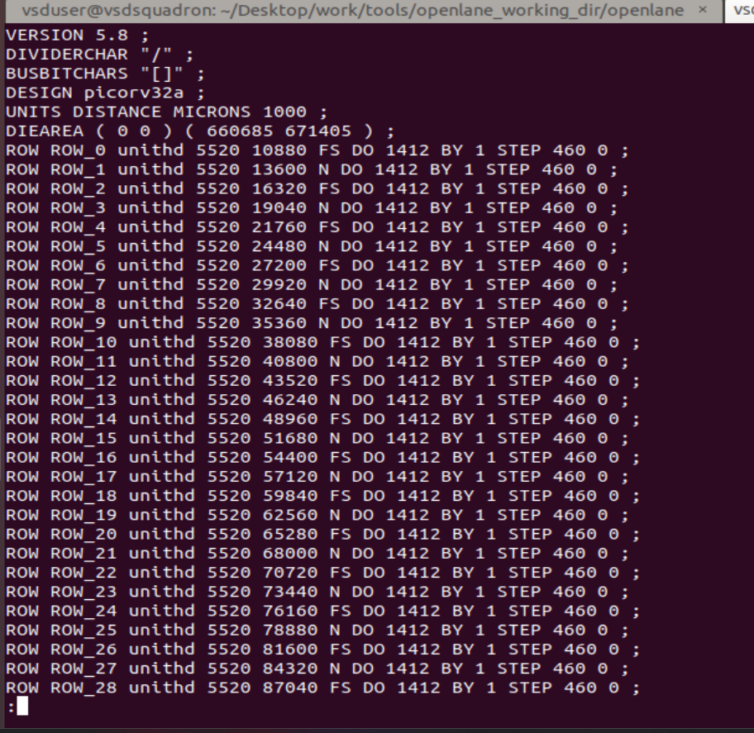

After entering magic -T command it lunches the magic tool and the below window

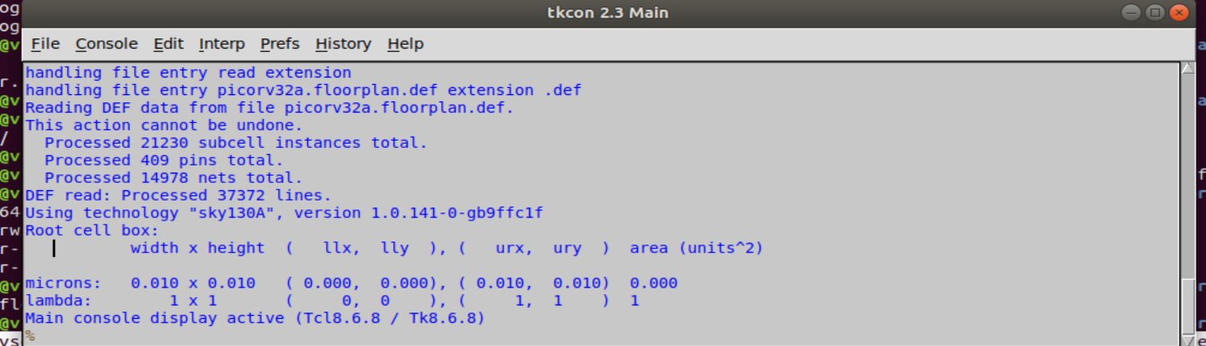

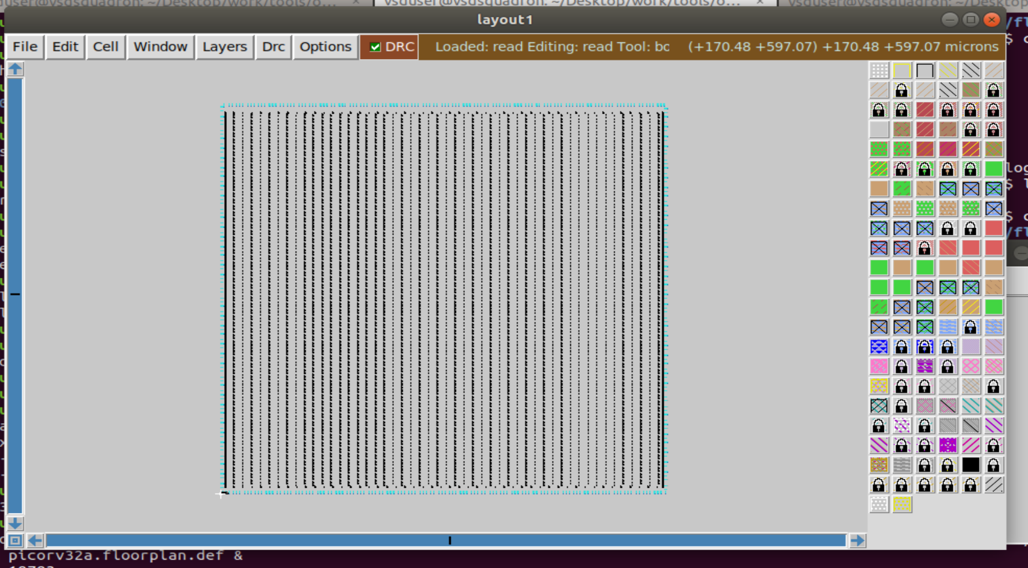

When we select the particular pin and highlight and check the what pin and what metal layer is present in horizontal tickon window and same for vertical pin also

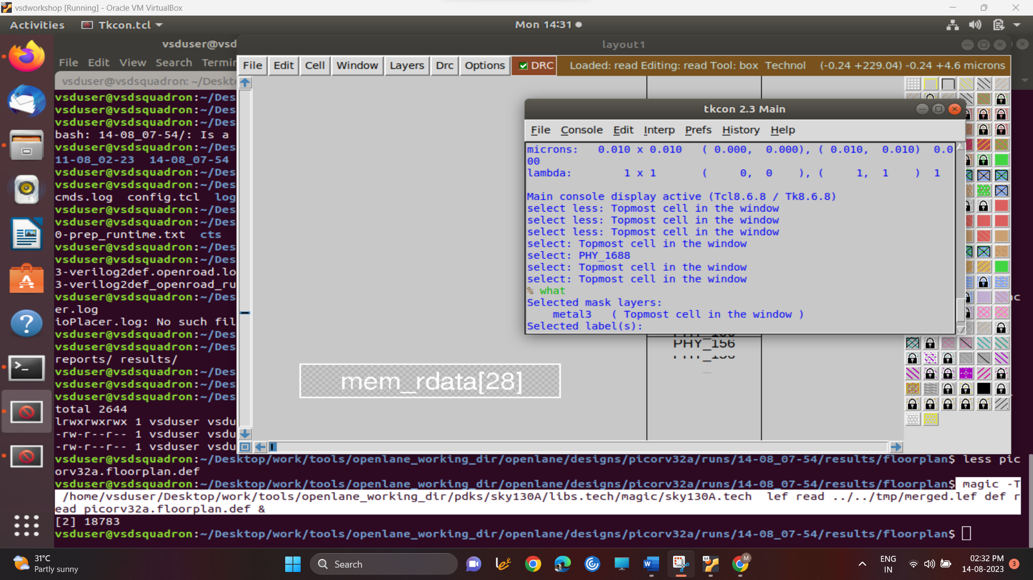

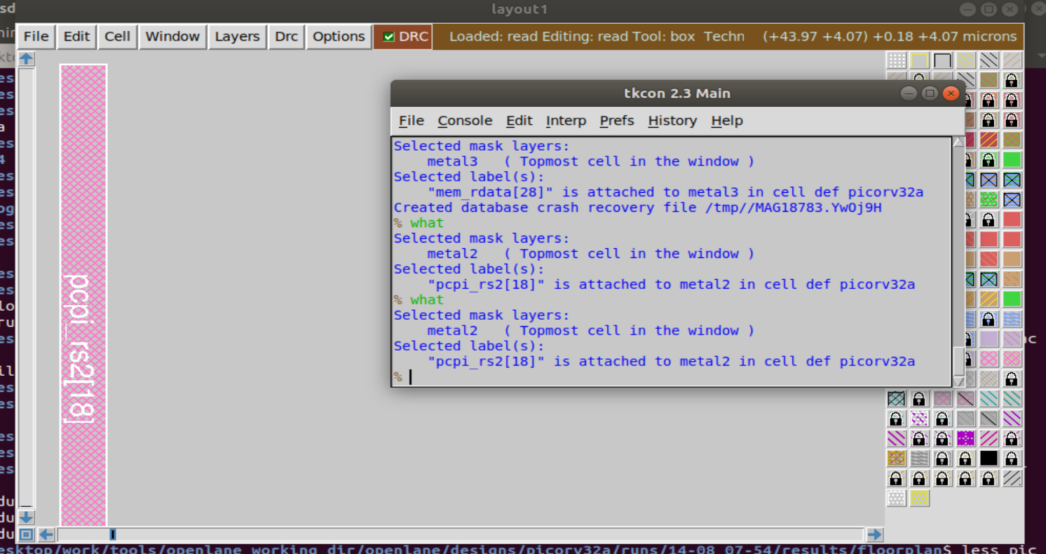

Some of the standard cells present at the bottom corner of the floorplan 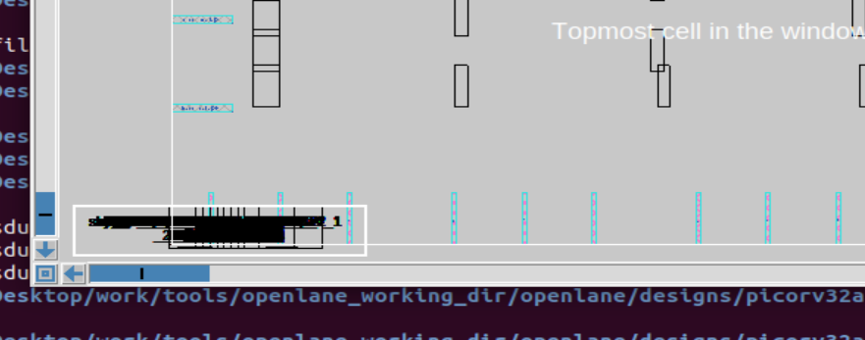

Placement

Placement of the standard cells in cell rows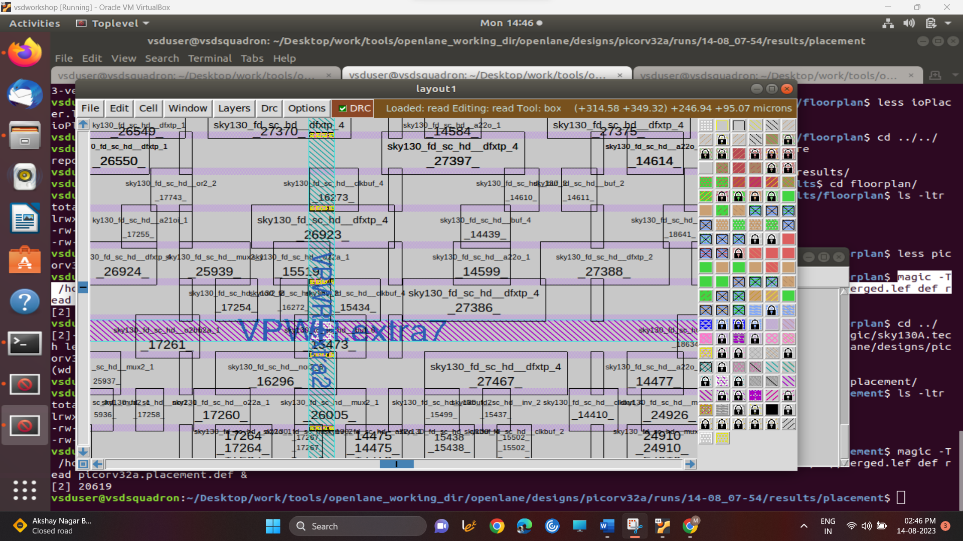

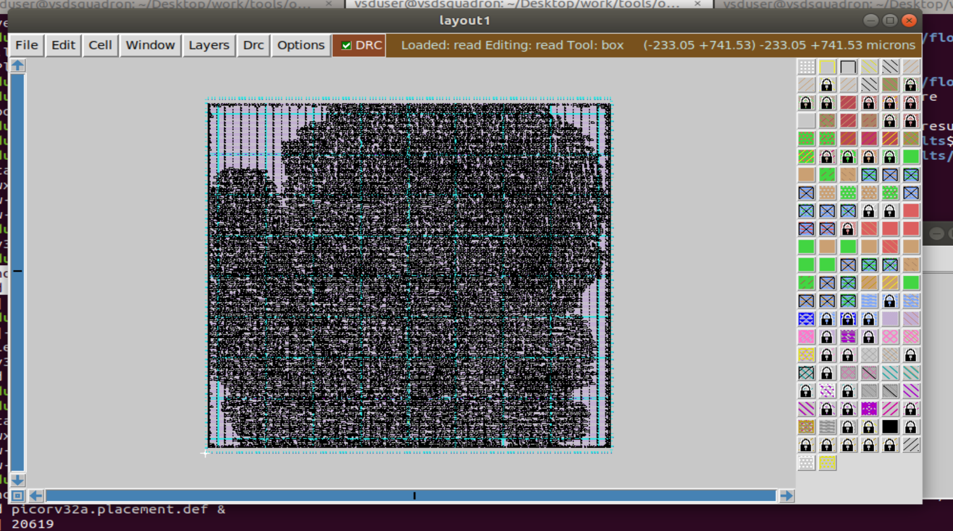

Inverter

